**CSIS 2260 - Lab #6**

***Introduction to Linux Commands and Scripting***

20

Due date: 20:59 March 5, 2021 (Pacific Time)

**Name: Stephen Joy Student No.: 300329148 Section: 012**

**DO NOT upgrade to Ubuntu 20.04 LTS if the message prompts.**

**You may not use the numeric keypad on your keyboard in Ubuntu. It is turned off by default.**

**Insert the required screenshots in the Word file. Do not submit the screenshots separately.**

**Write down your answers in the highlighted areas.**

**Objectives:**

To learn UNIX commands for file management, I/O redirection, file system management, and process management.

**Equipment/Document Required:**

1. A PC with VirtualBox installed and Ubuntu VM created.
2. The document *Introduction to UNIX Commands and Scripting*.
3. **UNIX Tutorial**  **[_____/3]**

Refer to the document *Introduction to UNIX Commands and Scripting* for this lab. You are required to complete Sections 2.4 to Section 5 (pages 6-17).

Note: use the command **man** if you need more information on how to use a command.

**Exercise 2c**

How can you view the last 15 lines of the file **sample.txt**? What was the command used?

**tail -15 sample.txt**

**Exercise 4b**

Using pipes, display all lines of **list1** and **list2** containing the letter 'p' and sort the result. What was the command used?

**cat list1 list2 | grep p | sort**

1. **Review Exercise**  **[_____/17]**

Carry out the following steps and give the command(s) used on the right.

|  |  |  |
| --- | --- | --- |
|  |  | Command(s) used |
| 1 | Create a file **ex1** under your **home directory** by using the command on the right. | **man less > ex1** |
| 2 | Display the file using the command on the right. | **cat ex1** |
| 3 | Display the first 10 lines of the file **ex1**. | **head ex1** |
| 4 | Display the last 10 lines of the file **ex1**. | **tail ex1** |
| 5 | Search the file **ex1** for the word **Display** and show the corresponding lines. | **grep display ex1** |
| 6 | Search the file **ex1** for the words **Display** and **display**, i.e., ignoring the case distinction, and show the corresponding lines. | **grep -i display ex1** |
| 7 | Search the file **ex1** for the words **Display** and **display**, i.e., ignoring the case distinction, and count the number of lines that contain the word in the file.  How many lines are there that contain the two words? **61**  Take a screenshot of the terminal window that display the command used and the result and insert it after the table. | **grep -ic display ex1** |
| 8 | Create a new file **ex2** and enter the following into the file.  Mary  Jack  Alice  What was the command used for creating the file? | **cat > ex2** |
| 9 | Display the content of the file **ex2**. | **cat ex2** |
| 10 | Append the following to the file **ex2**.  Nelson  Betty  Kim  What was the command used for appending the file? | **cat >> ex2** |
| 11 | Sort the items in file **ex2** and save the output to a new file **text**. | **sort < ex2 > text** |
| 12 | Display the content of the file **text**. | **cat text** |
| 13 | Using pipes, count the number of files under your home directory starting with the characters **ex**. | **ls ex* | wc -l** |
| 14 | List the contents of your home directory to confirm your answer. Take a screenshot of the terminal listing the contents of your home directory and insert it after the table. | **ls** |
| 15 | Change the access right of your file **ex1** so that ONLY you have the read/write access to the file. | **chmod go-r ex1** |
| 16 | List the contents of your home directory to confirm your answer. Take a screenshot of the terminal showing the permissions of the files and insert it after the table. | **ls -l** |
| 17 | Create a job **sleep 500** | **sleep 500** |
| 18 | Stop the job and move it to the background. | **^Z bg** |
| 19 | Use **ps** to view the running processes. Take a screenshot that displays the running processes and insert it after the table. | **ps** |
| 20 | Terminate the sleep process. | **kill 15154** |



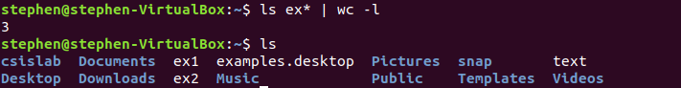

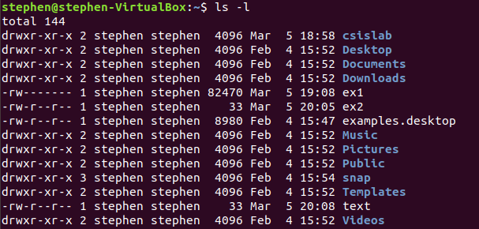

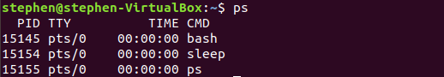

1. **Shutdown the Virtual Machine**
2. Power off the Ubuntu virtual machine.
3. Close Oracle VM VirtualBox Manager.

**Submission**

1. Save your lab file as YourFirstname_yourID_Lab6.docx.
2. Submit the WORD file through Blackboard before the due (do not send labs by email please. Any lab submitted by email will be ignored). Late submissions will not be marked, and the student will lose the mark of that lab.
3. You may submit your work multiple times, but only the LAST submission before the due will be graded.